5.23: a) For the net force to be zero, the applied force is
b) The acceleration is 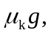and 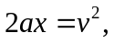 so 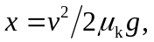 or 